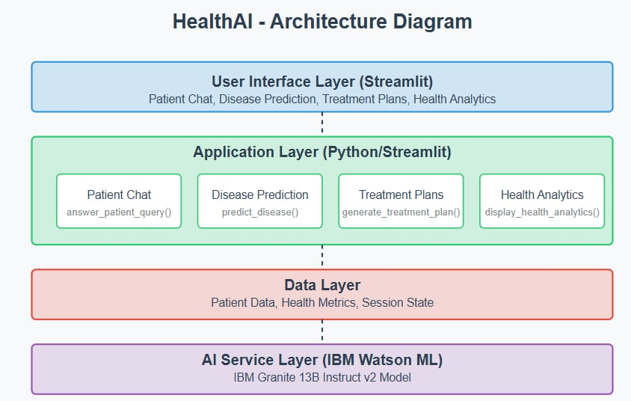

The Health AI Architecture Diagram illustrates the layered structure of the Health AI system, designed to deliver intelligent healthcare assistance using IBM’s Granite model.

At the top layer, the User Interface Layer (Stream lit) handles user interaction. It provides access to key features such as Patient Chat, Disease Prediction, Treatment Plans, and Health Analytics. This interface is built using Stream lit, offering a clean and interactive front end for users.

**Technical Architecture:**

Here is a high-level architecture for **Health AI**:

1. Frontend Layer (User Interface)

* Web/mobile UI for patients and doctors.
* Voice assistant or chatbot integration.
* Authentication via OAuth2 or SSO.

2. Middleware/API Gateway

* Routes user queries to the appropriate backend services.
* Performs input validation and security checks.
* Offers REST/GraphQL API interfaces.

3. Application Backend

* Intent Classification: Determines what the user is asking (e.g., symptom check, appointment booking).
* Context Manager: Maintains conversational context for follow-up queries.
* Prompt Engineering Engine: Prepares prompts for IBM Granite models based on user input.

4. IBM Granite Foundation Model (via watsonx.ai)

* Processes input using healthcare-optimized LLM.
* Supports tasks such as:
  + Symptom analysis.
  + Natural language Q&A on medical topics.
  + Summarization of patient records.
  + Extraction of key information from unstructured text.
* Hosted and fine-tuned in a secure cloud environment with governance and explainability features.

5. Data Layer

* EHR/EMR Integration: Access to patient records via HL7/FHIR APIs.
* Medical Knowledge Base: Drug databases, ICD-10 codes, and clinical guidelines.
* Feedback Store: Logs user interactions for continuous model fine-tuning and QA.

6. Security & Compliance

* HIPAA, GDPR, and other compliance layers.
* Data encryption at rest and in transit.
* Audit trails and access control.

🔹 Prerequisites

To build and deploy Health AI, the following are required:

✅ Technical

* IBM Granite models access via watsonx.ai.
* Cloud infrastructure (IBM Cloud, AWS, or Azure).
* Integration with EHR systems via FHIR/HL7.
* APIs for scheduling, records, and user management.
* Secure backend with data privacy layers.

✅ Human Resources

* AI/ML Engineers with experience in LLMs and healthcare NLP.
* Backend and frontend developers.
* Healthcare domain experts for prompt tuning and validation.
* Compliance officers to handle data privacy regulations.

✅ Tools & Frameworks

* IBM watsonx.ai
* IBM Cloud Pak for Data
* React/Flutter for frontend
* Python/FastAPI for backend.

Top of Form

Bottom of Form